Shopee Seller Advisor — BA Discovery Pack
Nov 3, 2026 · @The Kiet Ly

Executive summary
Shopee Seller Advisor (working name) is an AI decision assistant that turns a seller's own Shopee data into a short weekly list of explained actions: what to reprice, restock, promote or drop.
Why now. Vietnam's four main marketplaces sold about 442,000 billion VND in the first nine months of 2026, up 44.47% year on year. Yet shops with at least one sale fell to 470,300 in Q3 2026, down 10.68% on Q2. Growth is concentrating in fewer, better-run shops, so decision speed and accuracy now decide who survives.
The reference model. Chinese platforms have moved merchant tools from dashboards to "see, diagnose, act" assistants: Alibaba's Business Advisor (生意参谋), Tmall's AI war room, JD's Jingmai AI centre with 60+ tools. Vietnam's tools mostly stop at market data. The bet is that a Vietnamese-first, profit-aware version of that pattern can win domestic SME sellers.
The MVP.
- Seller uploads Seller Centre exports; buyer personal data is stripped in the browser before upload.
- Seller adds unit costs, so the tool shows true profit per SKU after fees and discounts.
- Every week the tool proposes up to 5 ranked actions, each with its evidence, expected impact and confidence.
- The seller accepts or dismisses each one; the tool measures the outcome after 7 and 14 days.
- Competitor prices are entered by the seller, never scraped.
- Vietnamese UI, English documentation. Next.js on Vercel, Neon Postgres in Singapore. A Shopee Open Platform adapter follows once partner approval comes through.
Decision needed before public launch: a Vietnamese lawyer's opinion on data localisation and cross-border transfer (see Legal and compliance). It decides whether Neon in Singapore can be the primary store.

Problem and opportunity
Most small Shopee sellers can see their numbers but cannot tell which decision to make next, and the market is now punishing slow or wrong calls.
Problem statement
The problem of | pricing, stock and promotion decisions made from gut feel and scattered Seller Centre reports
affects | small and mid-size non-Mall Shopee sellers, many of them household businesses (hộ kinh doanh)
the impact is | thinner margins after fee changes, dead stock, missed demand, shops dropping out
a good solution | tells the seller each week the few actions most likely to raise profit, why, and how to do them
Market signals (Metric, via Vietnamese press):
- Shopee held 56.04% of 2025 marketplace GMV, down from 64% in 2024; TikTok Shop rose from 29% to 41.31%. By Q3 2026 the gap was 1.7 percentage points. source, source
- In Q3 2026, Mall shops were 3.54% of selling shops on Shopee and TikTok Shop but took 36.8% of GMV. The other ~96% of shops share what is left. source
- Shops with at least one sale fell to 470,300 in Q3 2026, down 2.47% year on year and 10.68% on Q2.
- In May 2026 Shopee and TikTok Shop changed fixed, transaction and commission fees. On 28 May the National Competition Commission asked Shopee to review and hold some new fees. source
- Domestic sellers and warehouses produced 95.6% of Shopee's Q3 2026 GMV, about 69,800 billion VND. The customer base for this product is local.
Opportunity. Fee pressure plus a two-platform race makes profit per SKU, not GMV, the number sellers most need, and the platform cannot compute it because it does not know the seller's costs.
Open item: a Shopee-only count of sellers by GMV band is needed to size the market; current public figures mix all four platforms.

Target users and personas
The MVP is built for the owner-operator who runs a small shop from a phone; the team operator is secondary and the agency operator waits for Phase 3.
Persona | Who | Jobs to be done | Pains | What good looks like
Chị Lan, owner-operator (primary) | Household business, home and living, 1–2 helpers, 50–300 SKUs, Shopee only | Know which SKUs make money after fees; when to restock; whether a campaign is worth joining | Fees changed and she cannot see the effect; campaign discounts eat margin; no time for spreadsheets | Opens the app Monday, sees 3–5 actions in Vietnamese, done in 15 minutes
Anh Minh, shop operator (secondary) | Small brand aiming for Mall, 3–10 staff, Shopee plus TikTok Shop | Weekly team review; ad budget split; watch 5–10 competitors | Data spread across exports; reports take hours; no single profit view | One weekly report the team trusts, with actions assigned
Hà, agency operator (Phase 3) | Freelancer or agency running 3–10 client shops | Client reporting; batch recommendations | Repeating the same analysis per shop | Multi-shop view, white-label report
Not targeted: Mall brands with in-house BI teams, and Chinese cross-border sellers already served by tools such as Zhixia (知虾).
These are proto-personas from desk research. Phase 0 validates them through 8–10 seller interviews, which also supply real export files to build the parser against.

Competitive landscape
Chinese platforms show where seller tools are heading, from dashboards to assistants that diagnose and act, while Vietnamese tools mostly stop at market data.
Tool | Owner, market | What it does | Lesson for us
Business Advisor (生意参谋) | Alibaba, Taobao and Tmall | AI market-insight monitor: consumer demand, industry and competitor analysis; made free to merchants in 2024 | Free native analytics is the baseline; compete on actionability, not data volume
Tmall AI war room, upgraded 生意管家 | Alibaba, 2026 | Diagnoses product weaknesses, predicts likely hits | A diagnose step between data and action
Jingmai AI business centre (京麦AI经营中心) | JD, Sept 2026 | 60+ AI tools, natural-language "AI experts"; every operation needs merchant authorisation and is fully traceable | Human-approved, auditable actions
Compass AI ask-the-data (罗盘AI问数) | Douyin | Merchants query shop data in natural language | Q&A over the seller's own data
Kuaishou digital employee | Kuaishou | Always-on assistant to see, diagnose and act across operations | The see, diagnose, act loop as product spine
Zhixia (知虾) | Guangzhou Menglar, 9 Shopee markets | Market and product-selection analysis, keyword mining, shop analysis, competitor monitoring, browser plugin; Chinese UI | Proves demand for Shopee analytics; serves cross-border sellers, not Vietnamese SMEs
Metric | Vietnam | Sales data across Shopee, Lazada, Tiki, TikTok Shop; best-seller lists; tracks up to 30 competitor shops | Local market-data incumbent; possible licensed-data partner later
Shopee Seller Centre | Shopee Vietnam | Adding AI to live streaming, short video, customer service and data analytics (July 2026) | Generic features will be copied by the platform
Where we differentiate
- True profit. The platform does not know cost of goods, packaging or labour; the seller tells us, so margin per SKU is real.
- Actions, not reports. At most 5 ranked actions a week, each with expected impact and a step-by-step checklist.
- Explainable. Every recommendation shows the numbers behind it. Chinese press coverage reports merchants still doubt algorithm interpretability and fear tools that need long learning.
- Vietnamese-first, phone-first, written for household-business owners rather than analysts.
- Platform-agnostic data model, so TikTok Shop can follow quickly given the 1.7-point share gap.
Pricing for these tools was not checked; add it in Phase 0.

Legal and compliance (Vietnam)
Four new laws and Shopee's own data policy shape this product; data localisation and cross-border transfer decide the hosting design, so they need a lawyer's opinion before public launch.
This register summarises law-firm briefings, not the legal texts themselves. It is not legal advice; confirm each row with Vietnamese counsel.
Rule | In force | What it means here | Design response
Personal Data Protection Law 91/2025/QH15 + Decree 356/2025/ND-CP | 1 Jan 2026 | Consent must be verifiable; no default consent or pre-ticked boxes. Requests: acknowledge in 2 working days, access or correction in 10 days, consent withdrawal in 15, deletion in 20. Cloud processing abroad counts as a cross-border transfer, needing a transfer impact assessment within 60 days via the Ministry of Public Security portal. Household businesses are exempt from a DPO and impact assessments; small firms get a 5-year DPO grace only if they avoid sensitive data, stay under 100,000 people and are not data-processing service providers, which a SaaS like this may be. Fines for transfer breaches reach 5% of prior-year revenue | Consent ledger; self-serve export and delete; data inventory; breach runbook; choose the operating entity with these exemptions in mind
Cybersecurity Law 116/2025/QH15 + decrees of 19 Aug 2026 | 1 Jul 2026 | For a company incorporated in Vietnam, storing user personal data, user-generated data and relationship data inside Vietnam is automatic if it provides an enumerated service, which includes services that store and share data in cyberspace. Minimum 24 months | Open question: is a seller-analytics SaaS in scope? Neon has no Vietnam region, so keep the storage layer swappable and price a Vietnamese cloud fallback
E-commerce Law 122/2025/QH15 | 1 Jul 2026 | E-commerce support service providers must supply data to authorities on request and ensure data security and traceability (Arts. 33–36). Platforms must publish policies and complaint channels in Vietnamese | Confirm whether we are a support provider; keep audit logs; Vietnamese terms, privacy policy and complaint channel
AI Law 134/2025/QH15 | 1 Mar 2026 | Risk tiers: high, medium, low. Providers self-classify before use. Medium risk covers systems users might not recognise as AI; it needs transparency, a classification dossier and notice to the Ministry of Science and Technology. Low risk is reviewed only after incidents | Label every AI output; write a classification memo (likely low, possibly medium with chat); keep technical docs; seller approves every action
Shopee Open Platform Data Protection Policy | Current | Customer name, phone, email and address may be kept only as long as needed and never beyond 90 days, then securely destroyed. Shopee Vietnam does not accept individual developers (source) | Never store buyer personal data at all; apply as an ISV through the registered household business
Shopee terms on data collection | Current | Automated collection of competitor listings is out of scope by decision | Competitor data is seller-entered only
Terms of service and privacy policy checklist (Vietnamese version prevails)
- ☐ Governing law Vietnam; dispute route; Vietnamese text controls over English
- ☐ AI output is decision support, not a guarantee; the seller makes and owns every business decision
- ☐ Data roles: we process the seller's business data on their instructions; buyer personal data is not collected
- ☐ Separate, unticked consents: service processing; optional anonymised benchmarking; marketing
- ☐ Sub-processors and their countries (Vercel, Neon in Singapore, the LLM provider), with the cross-border disclosure
- ☐ Retention periods; how to export, correct and delete, with the statutory response times
- ☐ Acceptable use: no uploading other people's personal data; no illegal goods analysis
- ☐ Liability cap, service availability, change notice, complaint channel and response time
- ☐ Plain wording: under the Civil Code, unclear standard-form terms are read against the drafter (from memory, confirm with counsel)

Product vision and MVP scope
The MVP proves one loop end to end: upload, see true profit, get a few explained actions, act, and learn whether they worked.
Vision. For Vietnamese marketplace sellers who make pricing, stock and promotion calls every day, Seller Advisor is an AI business advisor that turns their own data into a short, explained action list. Unlike dashboards and market-data tools, it accounts for the seller's real costs and tracks whether each action paid off.
Priority | Capability
Must | Sign-up, shop profile, separate consents
Must | Upload Seller Centre exports (XLSX, CSV) with format detection; buyer personal data removed in the browser
Must | Unit-cost entry per SKU by template or inline edit
Must | Profit view: revenue, platform fees, discounts, cost of goods, contribution margin per SKU and week
Must | Weekly action list: up to 5 ranked recommendations with evidence, impact range and confidence
Must | Accept, dismiss with reason, mark done; outcome measured at 7 and 14 days
Must | Competitor tracker: seller adds listing link and observed price; price gaps feed recommendations
Must | Demo shop with synthetic data, clearly labelled, for onboarding and the portfolio demo
Must | Vietnamese UI, phone-first layout; data export and deletion
Should | Ask-your-data chat in Vietnamese, limited to the seller's own data
Should | Discount what-if simulator for campaigns
Should | Weekly digest by email
Could | Zalo digest (needs an Official Account)
Won't (MVP) | Changing anything inside Shopee automatically; scraping; TikTok Shop and Lazada; multi-shop agency view; paid plans

Data strategy
Phase 1 runs entirely on files the seller exports from Seller Centre, stripped of buyer details before they leave the browser; the Open Platform adapter later writes into the same data model.
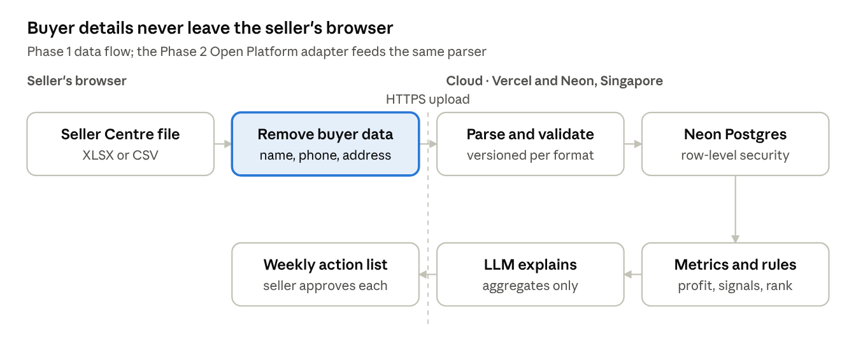
data flow · browser to cloud and back
The privacy boundary is the dashed line: only stripped files cross it, and only SKU-level aggregates reach the language model.
Source | Phase | Data | Notes
Seller Centre exports (XLSX, CSV) | MVP | Orders, SKUs, revenue, fees, discounts, product traffic | Exact files and columns to confirm from real seller samples; one versioned parser per export type
Seller input | MVP | Unit cost, packaging cost, target margin, stock on hand | Template upload plus inline edit
Competitor tracker | MVP | Competitor listing link, price, date observed, note | Seller-entered; no automated collection
Demo dataset | MVP | Synthetic shop with 12 months of history | Labelled as demo everywhere it appears
Shopee Open Platform (OAuth) | Phase 2 | Orders, products, ads | Needs ISV approval through a registered business; 90-day cap on restricted data
Licensed market data (for example Metric) | Phase 3 option | Category benchmarks | Commercial agreement required
Principles
- Minimise. Buyer name, phone, email and address columns are dropped in the browser and never uploaded. The seller sees what was removed. Order IDs are hashed.
- One canonical model. Shop, SKU, order line, fee, daily metric, cost, competitor observation, recommendation and outcome. Each platform gets an adapter that maps into it.
- Provenance. Every metric traces back to an upload and row; every recommendation cites the metrics it used.
- Isolation. Postgres row-level security per shop, enforced in the database, not only in application code.
- Hosting. Vercel functions and Neon Postgres in Singapore (aws-ap-southeast-1); a Neon project's region is fixed at creation (Neon regions). This is a cross-border transfer, so a transfer impact assessment is filed, and the localisation question stays open until counsel answers.
- Retention. Raw upload files deleted within 7 days of parsing; derived data kept while the account is active; deletion requests completed within the 20-day statutory window.

AI recommendation approach
Recommendations come from computed metrics and explicit rules first; the language model only explains and phrases them, so every number a seller sees was calculated, not generated.
- See. Compute per-SKU weekly metrics: contribution margin after fees and cost of goods, units, sell-through, days of stock cover, price gap to tracked competitors, campaign uplift.
- Diagnose. A rule library raises signals, for example margin below target, stock cover shorter than restock lead time, price well above the competitor median, many views but few orders. Thresholds use the seller's settings or category defaults.
- Prioritise. Score each candidate action by expected profit impact × confidence × ease; keep the top 5.
- Explain. The LLM receives a structured signal payload and writes a short Vietnamese explanation. Output is schema-validated, and any number not present in the payload fails the check.
- Act. The seller accepts and follows a checklist in Seller Centre. Nothing changes in Shopee automatically.
- Learn. Compare the 7- and 14-day result with the pre-action baseline and adjust confidence weights per rule.
Illustrative card from the demo shop (synthetic numbers):
**Tăng giá "Kệ gia vị 3 tầng" từ 189.000 ₫ lên 199.000 ₫**
Biên lợi nhuận sau phí hiện 6% (mục tiêu 15%). Giá của bạn thấp hơn 12% so với trung vị 3 đối thủ bạn theo dõi. Lượt bán 4 tuần qua ổn định.
Tác động ước tính: +0,9 đến +1,4 triệu ₫/tháng · Độ tin cậy: trung bình
_Gợi ý do AI tạo, dựa trên dữ liệu bạn đã tải lên._
Guardrails
- Every AI output is labelled as AI-generated, in line with the AI Law's transparency duty.
- No automatic execution; each action is approved by the seller and logged, the pattern JD uses for its merchant AI.
- An "insufficient data" state replaces a guess when history is too short (proposed minimum: 4 weeks).
- No buyer personal data ever reaches the model; payloads carry SKU-level aggregates only.
- The LLM provider must not train on customer data; its processing country is listed in the privacy policy.
- A golden set of demo-shop scenarios runs as a regression test before any prompt or model change.
- Each seller sees the track record of past recommendations, including the ones that did not work.

Requirements
Sixteen functional requirements cover the MVP and Phase 2; the non-functional targets are proposals to confirm during design.
Functional
ID | Requirement | Priority
FR-01 | Sign up with email or Google; verify email | Must
FR-02 | Capture separate, unticked consents; store who, what, when and policy version | Must
FR-03 | Upload XLSX or CSV exports; detect type; preview column mapping; reject unknown formats with a clear message | Must
FR-04 | Remove buyer personal data columns in the browser before upload and show the seller what was removed | Must
FR-05 | Bulk-upload unit costs from a template; edit inline | Must
FR-06 | Compute weekly per-SKU revenue, fees, discounts, cost of goods, contribution margin, units and stock cover | Must
FR-07 | Generate up to 5 ranked recommendations weekly and on demand | Must
FR-08 | Show evidence, impact range, confidence and the data used on every recommendation | Must
FR-09 | Accept, dismiss with reason, or mark done; measure outcome at 7 and 14 days | Must
FR-10 | Competitor tracker with listing link, price and date; raise price-gap signals | Must
FR-11 | Self-serve data export and account deletion | Must
FR-12 | Demo shop mode with synthetic data | Must
FR-13 | Vietnamese ask-your-data chat limited to the seller's own data | Should
FR-14 | Discount what-if simulator | Should
FR-15 | Weekly email digest | Should
FR-16 | Shopee Open Platform OAuth sync | Phase 2
Non-functional
Area | Target
Security | OWASP ASVS Level 2; TLS everywhere; encryption at rest; secrets only in environment config; row-level security per tenant; rate limiting; audit log; dependency scanning; optional MFA
Privacy | No buyer personal data stored; data-subject requests within Decree 356 timelines; 72-hour breach notification runbook
Performance | Dashboard p95 under 2 s on 4G for 50,000 order lines per quarter; a 20 MB file parsed in under 30 s
Availability | 99.5% monthly during beta
Accessibility | WCAG 2.2 AA
Localisation | vi-VN default; VND as 1.234.000 ₫; dates dd/MM/yyyy; Asia/Ho_Chi_Minh time zone
Observability | Structured logs, error tracking, LLM cost and latency per request
AI quality | Zero numbers in explanations that are absent from the payload, checked on every golden-set run
Maintainability | TypeScript strict mode, automated tests in CI, migrations versioned

User stories
Eight stories cover the MVP loop for Chị Lan; acceptance criteria are written as Given / When / Then so they can become automated tests.
ID | Story | Acceptance criteria
US-01 | As a new seller, I want to choose exactly what I consent to, so that I trust the tool with my data | Given the sign-up screen, when it loads, then each consent is a separate unticked box. When I submit without the required consent, then sign-up is blocked with a reason. When I submit, then a consent record with timestamp and policy version is stored
US-02 | As a seller, I want to upload my Seller Centre order export, so that I don't retype data | Given a valid export, when I upload it, then the file type is detected and a mapping preview shows. Given buyer name, phone or address columns, when the file is read, then those columns are removed before upload and listed to me. Given an unknown format, then I see what is wrong and a link to the guide
US-03 | As a seller, I want to add unit costs in bulk, so that profit is accurate | Given a downloaded template with my SKUs, when I upload it filled in, then costs are saved per SKU. Given missing costs, then affected SKUs are flagged and excluded from margin rankings
US-04 | As a seller, I want to see true profit per SKU each week, so that I know what earns money | Given uploaded orders and costs, when I open the profit view, then each SKU shows revenue, fees, discounts, cost of goods and contribution margin, and every number links to its source rows
US-05 | As a seller, I want a short list of actions each Monday, so that I act fast | Given at least 4 weeks of data, when the weekly run completes, then at most 5 actions are shown in rank order, each with evidence, impact range, confidence and an AI label. Given less data, then an insufficient-data message replaces the list
US-06 | As a seller, I want to know whether an action worked, so that I trust future advice | Given an action marked done, when 7 and 14 days pass, then the card shows the change in units and margin against the baseline, and the result counts toward that rule's track record
US-07 | As a seller, I want to log competitor prices, so that pricing advice reflects my market | Given a competitor listing link and price, when I save it, then it appears with its date. Given my price differs from the competitor median by more than my threshold, then a pricing signal can enter the action list
US-08 | As a seller, I want to delete my account and data, so that I stay in control | Given I confirm deletion, then I receive an acknowledgement at once and all my data is deleted within 20 days, with a confirmation message

Success metrics
The north-star metric is profit-positive actions per active shop per month: accepted recommendations whose 14-day margin beat the baseline. It measures faster and more accurate decisions directly, not page views.
Metric | Definition | Beta target (12 weeks)
Activation | Sign-ups that upload an export and costs within 7 days | 40%
Time to first insight | Median from sign-up to first recommendation | Under 15 minutes
Weekly engagement | Activated shops that open the action list each week | 60%
Acceptance rate | Accepted ÷ shown recommendations | 30%
Positive outcome rate | Accepted actions with margin above baseline at 14 days | 50%
Explanation trust | Average in-app rating of explanations, 1–5 | 4.0
Week-4 retention | Activated shops still active in week 4 | 40%
Guardrail: privacy | Buyer personal data incidents | 0
Guardrail: accuracy | Explanation numbers not found in the payload, golden set | 0
Targets are hypotheses; recalibrate after the first 20 beta sellers. LLM cost per active shop needs a budget once the provider is chosen.

Risks, assumptions and open questions
The two highest-exposure risks are Shopee shipping its own AI advisor and data localisation forcing a hosting change; both are addressed by design choices made now.
ID | Risk | Likelihood | Impact | Mitigation
R1 | Data localisation applies, forcing a hosting redesign | Medium | High | Legal opinion in Phase 0; storage behind an interface; quote a Vietnamese cloud provider
R2 | Seller Centre export formats change and break parsing | High | Medium | Versioned parsers, format detection, sample-file library, alert on unknown columns
R3 | Open Platform approval is slow or refused | Medium | Medium | Upload path is a complete product; apply through the household business
R4 | Shopee ships a native AI advisor | High | High | Differentiate on cost-aware profit, outcome tracking and cross-platform; add TikTok Shop early
R5 | Wrong recommendations erode trust | Medium | High | Rules first, visible confidence, insufficient-data state, public track record
R6 | Sellers will not enter unit costs | Medium | High | Template, category defaults, partial value from fee and discount analysis alone
R7 | LLM cost grows faster than revenue | Low | Medium | Small aggregate payloads, caching, a smaller model for phrasing
R8 | No own seller account to test with | High | Medium | Recruit 5–10 design-partner sellers; build on the demo dataset
Assumptions to validate
- Sellers can export orders and product performance from Seller Centre in a usable format.
- Most target sellers know, or can estimate, unit cost per SKU.
- Sellers will pay for decision support once value is proven; price point unknown.
- A household business can register as a Shopee Open Platform ISV.
Open questions
- ☐ Is a seller-analytics SaaS an enumerated service under the 2025 Cybersecurity Law localisation rules? (counsel)
- ☐ Is the product an e-commerce support service provider under the E-commerce Law, and a data-processing service provider under Decree 356? (counsel)
- ☐ AI Law tier: low, or medium once chat ships? (counsel plus classification memo)
- ☐ Which Seller Centre exports exist, and which columns do they carry? (5 seller samples)
- ☐ Shopee Vietnam ISV requirements for a household business
- ☐ Shopee-only seller counts by GMV band, for sizing
- ☐ Willingness to pay and pricing model (interviews)
- ☐ LLM provider and where it processes data

Roadmap and next steps
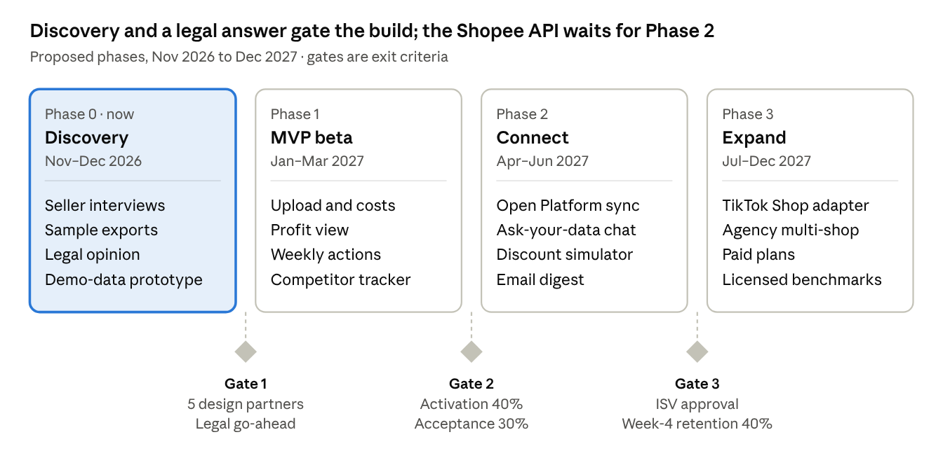
roadmap · 4 phases, 3 exit gates
Gates are exit criteria, not dates: if counsel rules out offshore storage at Gate 1, Phase 1 moves the primary database to a Vietnamese cloud before beta.
Next steps
- Review this pack, comment on anything that looks wrong, and settle a working name.
- Recruit 5–10 design-partner sellers and collect sample exports with buyer columns removed.
- Book a consult with a Vietnamese data-protection lawyer on the three open legal questions.
- Add the business line to the household business, then apply as a Shopee Open Platform ISV.
- Next deliverable: the system design pack, covering architecture, Neon schema with row-level security, security model, Vercel setup and parser design.
For the BA portfolio. This pack already shows the core artifacts: problem statement, proto-personas, competitive analysis, regulatory register, MoSCoW scope, functional and non-functional requirements, user stories with Gherkin criteria, a KPI set and a risk log. Phase 0 adds interview synthesis, current-versus-future process maps and a traceability matrix from requirement to story to test.

Sources
Market
- Metric Q3 2026 report coverage, Người Quan Sát (29 Oct 2026)
- Metric H1 2026 report coverage, Người Quan Sát (24 Jul 2026)
- Metric 2025 full-year coverage, Doanh nhân Pháp luật (15 Jan 2026)
- Shopee Vietnam AI strategy, Vietstock (Jul 2026)
Competitors
- Alibaba Group: Taobao and Tmall merchant AI tools, incl. Business Advisor
- Beijing News: platform merchant AI tools ahead of Double 11 2026
- Zhixia (知虾) App Store listing
- Metric user manual
Legal and platform
- Tilleke & Gibbins: Personal Data Protection Law overview
- Vietnam Briefing: Decree 356 requirements
- Le & Tran: data localisation under the 2025 Cybersecurity Law
- LNT & Partners via Conventus Law: E-commerce Law 2025
- Tilleke & Gibbins: AI Law 134/2025/QH15
- Zetpy: Shopee Open Platform Data Protection Policy clauses
- FPT Shop: Shopee Open Platform registration in Vietnam
- Neon documentation: regions

